Dependencies

📦 What Are Dependencies?
# Source: AI Source: Provided by: [Data Path: Persons Table -> ID Column: 1, Name_En Column: Motasem Essam] -> From: [Chatgpt (GPT‑5 Mini)] on [1/26/2026]
Dependencies are external packages, libraries, or modules that your application needs to run properly in production.

🔧 Why Are Dependencies Important?
# Source: AI Source: Provided by: [Data Path: Persons Table -> ID Column: 1, Name_En Column: Motasem Essam] -> From: [Chatgpt (GPT‑5 Mini)] on [1/26/2026]
Instead of writing all code from scratch, developers use pre-built tools or libraries to save time and ensure reliability. These tools become dependencies.

🧩 Examples by Language

✅ PHP (Composer)
# Source: AI Source: Provided by: [Data Path: Persons Table -> ID Column: 1, Name_En Column: Motasem Essam] -> From: [Chatgpt (GPT‑5 Mini)] on [1/26/2026]
In composer.json:
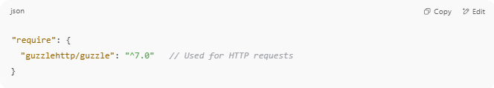
"require": {
"guzzlehttp/guzzle": "^7.0" // Used for HTTP requests
}

➡ Your project needs Guzzle to send HTTP requests. It will crash if Guzzle is missing.

✅ JavaScript (Node.js + npm)
# Source: AI Source: Provided by: [Data Path: Persons Table -> ID Column: 1, Name_En Column: Motasem Essam] -> From: [Chatgpt (GPT‑5 Mini)] on [1/26/2026]
In package.json:
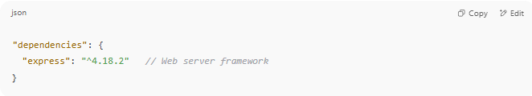
"dependencies": {
"express": "^4.18.2" // Web server framework
}

➡ You need Express to run your server.

🔄 Dependencies vs Dev Dependencies
# Source: AI Source: Provided by: [Data Path: Persons Table -> ID Column: 1, Name_En Column: Motasem Essam] -> From: [Chatgpt (GPT‑5 Mini)] on [1/26/2026]
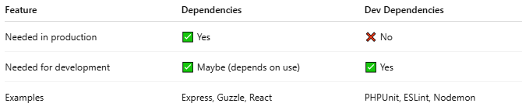

Feature | Dependencies | Dev Dependencies
Needed in production | ✅ Yes | ❌ No
Needed for development | ✅ Maybe (depends on use) | ✅ Yes
Examples | Express, Guzzle, React | PHPUnit, ESLint, Nodemon

📁 When Installed?

Composer:
# Source: AI Source: Provided by: [Data Path: Persons Table -> ID Column: 1, Name_En Column: Motasem Essam] -> From: [Chatgpt (GPT‑5 Mini)] on [1/26/2026]
- composer install → installs both require and require-dev (unless --no-dev is used)

Npm:
# Source: AI Source: Provided by: [Data Path: Persons Table -> ID Column: 1, Name_En Column: Motasem Essam] -> From: [Chatgpt (GPT‑5 Mini)] on [1/26/2026]
- npm install → installs everything
- npm install --production → skips devDependencies

💡 Real-Life Analogy
# Source: AI Source: Provided by: [Data Path: Persons Table -> ID Column: 1, Name_En Column: Motasem Essam] -> From: [Chatgpt (GPT‑5 Mini)] on [1/26/2026]
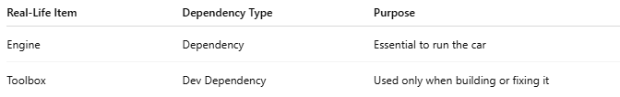

Real-Life Item | Dependency Type | Purpose
Engine | Dependency | Essential to run the car
Toolbox | Dev Dependency | Used only when building or fixing it

